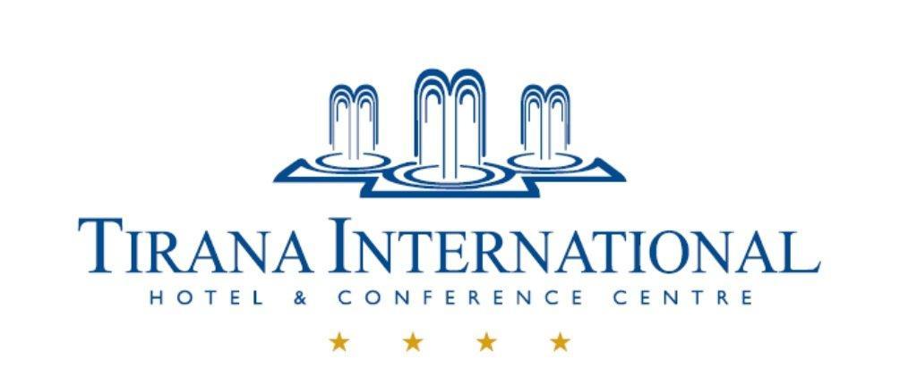

HOTEL RESERVATION FORM

Participants of SEE 5 Meeting have to return this form no later than 29 March 2016 to reservation@hoteltirana.com.al. After that date the Hotel does not guarantee the reservations but will proceed according to the room availability and with the same preferential rates.

Group: | RIPE NCC – 19 to 20 April 2016
Full Name:
Address:
Country:
Telephone:
Fax:
Email:

The following special room rate will be applied for your reservation. Please type “yes”, against the room you want.

 | STANDARD ROOM | € 80 | Room rate includes: breakfast, Wi-Fi internet access in the room as well as in the other public areas of the Hotel, Swimming Pool, Fitness Center, Sauna, Parking, Internet and computer usage in the Business Center, Portage Service 24/7
 | DOUBLE ROOM | € 90

DATE OF ARRIVAL: __________________ 14:00 p.m. Check in time
DATE OF DEPARTURE: __________________ 12:00p.m. Check out time

CC Type: | Visa | Master Card | Amex | Maestro
Card’s holder
Number:
Expiry date:

Guaranteed Reservation (credit card and signature are mandatory):
- After receiving the credit card details and the signed booking form the room will be blocked for you for the entire booking period.
- In the event of cancellation 7 days before the arrival date – no charges apply.
- In case of cancellations or no-show after 7 days before arrival date – full charges for the cancelled room nights will be applied to the credit card.
- All charges for the room nights & extras are subject to personal payment by the guests upon departure from the hotel.

I would like to arrange the airport transfer with the Tirana International Hotel

Airport -2 ways  (pick up & drop off) | 35 EURO

Flight details are needed to proceed with the reservation for the transfer service:

Flight details

Arrival date: | Airport: | Flight: | Landing time:
Departure date: | Airport: | Flight: | Pick up time:

Date: ________________________ Signature: ______________________________

Please sign and email a scanned copy to reservation@hoteltirana.com.al no later than 29 March 2016.

